SIMATS ENGINEERING (SAVEETHA SCHOOL OF ENGINEERING)
Department of Computer Science and Engineering
CO2_AT1 — CHART CONSTRUCTION TEST

Course Code: | DSA06 | Course Title: | Data Handling and Visualization
CO Assessed: | CO2 – Construction (BL3) | Assessment: | Assessment Tool 1 – Chart Construction
Weightage: | 20% of CIA | Total Marks: | 25 (5 Questions × 5 Marks)
CO2 Statement: | Apply appropriate chart construction techniques — correct chart type, axes, scales, and calculations — to accurately represent given data.(BL3)
Student Name: | Haritha S | Reg. No.: | 192324299
Section / Batch: | B.tech – AI&DS | Date: | 30/07/2026

Code of Conduct
I __________________________ (Name / Reg No) certify that this submission is my original work and that I have adhered to the guidelines specified for this assessment. I understand that any violation of academic integrity rules will result in disciplinary action.

Signature of the Student: _________________________

Instructions
- This test contains 5 questions, each carrying 5 marks. Total: 25 Marks.
- No negative marking. Unanswered questions carry zero marks.
- No calculators or electronic devices permitted.
- Duration: 75 minutes.
- Graph paper or a ruler is recommended for accurate, to-scale drawing.
- Show all calculations (e.g., percentages, angles, bin ranges, five-number summaries) as part of your answer.
- Every chart must include a title, correctly labeled axes, and a legend where applicable.

Annexure A – CHART CONSTRUCTION

Rubrics for Calculation ASSESSMENT RUBRIC
AT1 — Chart Construction Test
CO2 · BT3: Apply ·
This rubric is used to assess student responses to the CO2-AT1 Chart Construction Test, in which students are given a small dataset and must construct an accurate, correctly labeled chart of a specified type.

Criteria | Weightage | Level 4 – Exemplary | Level 3 – Proficient | Level 2 – Developing | Level 1 – Beginning
Understanding of Concepts | 25% | Demonstrates thorough, accurate understanding of the correct chart type, and the axes, scale, and elements required to construct it for the given data. | Good understanding of the required chart type and construction elements, with only minor gaps. | Basic understanding of chart construction, but with some misconceptions about the correct chart type, axes, or scale. | Poor understanding of core construction concepts; selects a chart type or elements fundamentally unsuited to the data.
Explanation | 25% | Shows detailed, clearly worked calculations (e.g., angles, bin ranges, five-number summary) and explains each construction step. | Shows clear calculations and construction steps, with adequate explanation for most parts. | Calculations or construction steps are shown but incomplete, or explanations are superficial. | Little or no working shown; calculations and construction steps are missing or unexplained.
Application | 20% | Effectively applies chart construction techniques to produce a complete, accurate chart correctly matched to the data. | Applies construction techniques to produce a correct chart, with only minor errors. | Limited application of construction techniques; the chart partially represents the data but has notable errors. | Fails to apply appropriate construction techniques; the chart does not correctly represent the data.
Organization | 15% | The chart is neatly and logically constructed, with a title, correctly labeled axes, a legend where applicable, and elements in a clear order. | The chart is well organized, with only minor issues in labeling, legend, or layout. | Basic construction; required elements (title, axes, legend) are present but poorly arranged or partly missing. | Poorly constructed; the chart is missing key elements such as a title, axis labels, or a legend.
Accuracy | 10% | The chart is completely accurate — all values, proportions, scales, and calculations correctly match the given data. | Mostly accurate, with only minor omissions or a small error in one value or calculation. | Partially correct; some plotted values, proportions, or calculations are missing or incorrect. | Largely inaccurate; major errors in plotted values, proportions, or calculations relative to the given data.

Scoring Guide
For each criterion, award a performance level (1–4) based on the descriptors above. Multiply the level achieved (as a percentage of 4, i.e., Level 4 = 100%, Level 3 = 75%, Level 2 = 50%, Level 1 = 25%) by the criterion's weightage, then sum across all five criteria to obtain the total score out of 100%.

Faculty In-charge | Course Coordinator | Head of Department
Signature: _______________ | Signature: _______________ | Signature: _______________
Date: ___________________ | Date: ___________________ | Date: ___________________

Problem 3 — Grouped (Clustered) Bar Chart (5 Marks)
Data: Quarterly revenue ($'000): Product A — Q1=200, Q2=250, Q3=300, Q4=280. Product B — Q1=180, Q2=220, Q3=260, Q4=310.
Task: Construct a grouped bar chart comparing Product A and Product B across all four quarters. Include a legend distinguishing the two products.

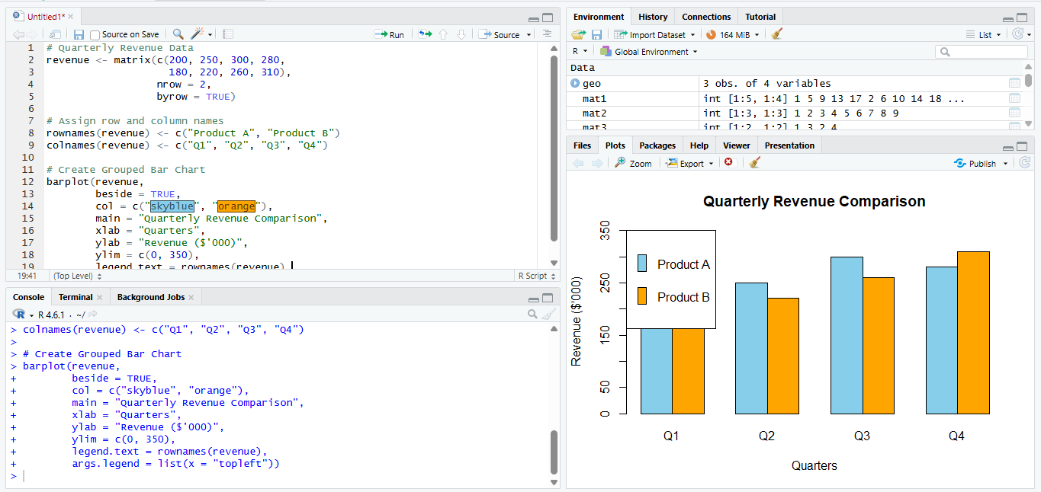

Problem 4 — Stacked Bar Chart (5 Marks)
Data: Department headcount by year: 2022 — Engineering=40, Sales=25, Support=15. 2023 —
Engineering=55, Sales=30, Support=20.
Task: Construct a stacked bar chart showing total headcount for each year, broken down by department,
with a legend for each department.

,

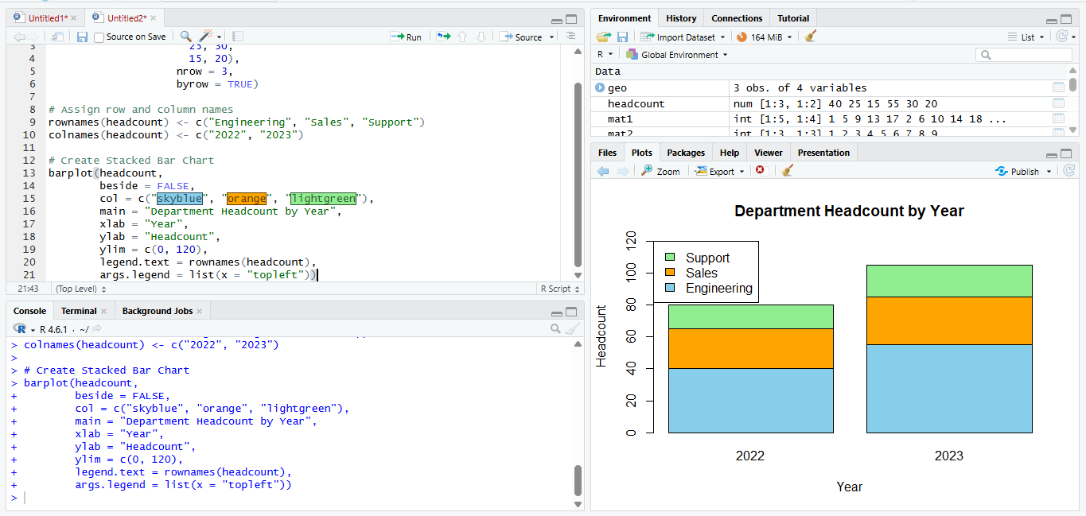
Problem 5 — Line Chart — Single Series (5 Marks)
Data: Daily temperature (°C) for one week: Mon=22, Tue=24, Wed=23, Thu=27, Fri=29, Sat=26, Sun=25.
Task: Construct a line chart plotting temperature across the week. Mark and label each individual data
point on the line.

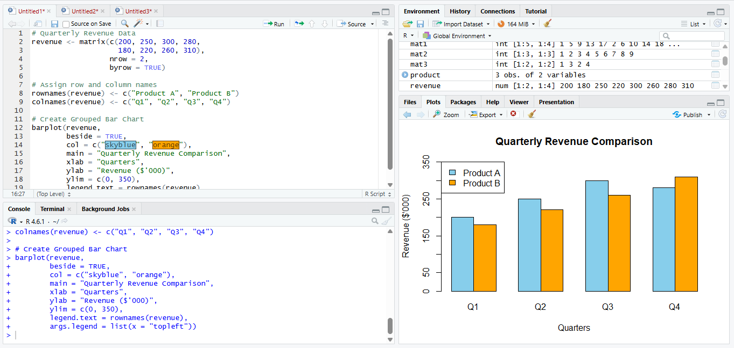

Problem 6 — Multi-Line Chart — Comparison (5 Marks)
Data: Monthly rainfall (mm): City A — Jan=50, Feb=40, Mar=60, Apr=80. City B — Jan=30, Feb=45,
Mar=35, Apr=55.
Task: Construct a multi-line chart comparing rainfall between both cities across the four months. Use distinguishable line colors and include a legend.

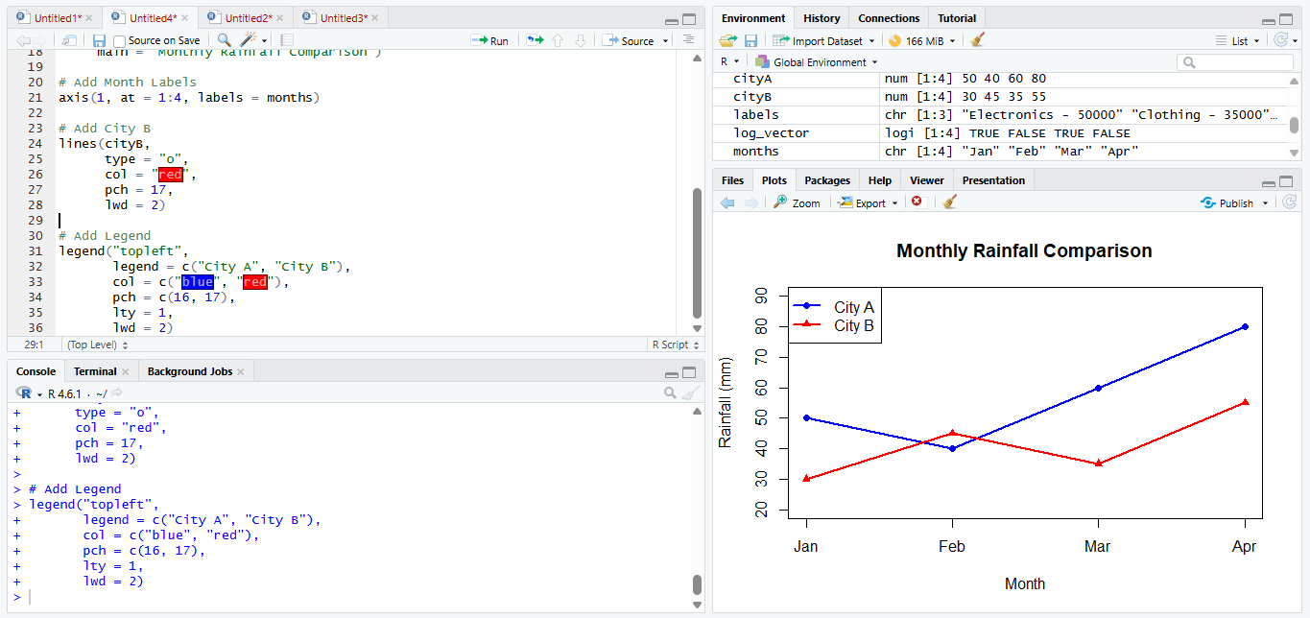

Problem 7 — Pie Chart — Angle Calculation (5 Marks)
Data: Market share: Company A = 40%, Company B = 25%, Company C = 20%, Company D = 15%.
Task: Construct a pie chart representing this market share. Show your calculation of the angle (in
degrees) for each company's slice before drawing it.

